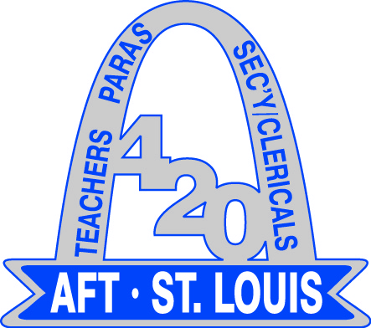
AFT St. Louis, Local 420

2024-2025 Local 420 Meetings

Executive Board Meetings
Local 420 Office
2710 Hampton Ave.
5:00 p.m. – 7:00 p.m.
1st Wednesday of the month

Sep 4th | Oct 2nd | Nov 6th | Dec 4th | Jan 8th | Feb 5th
Mar 5th | Apr 2nd | May 7th | Jun 4th | Jul 2nd

General Membership Meetings
IBEW, Local 1
5850 Elizabeth Avenue (St. Louis, MO 63110)
5:00 p.m. – 7:00 p.m.

meetings held per quarter

Wednesday, September 25, 2024
(JOINT MEMBERSHIP & BLDG. STEWARD)

*Wednesday, January 22, 2025
(Joint Membership & BLDG. Steward)

*Wednesday, March 22, 2025
(JOINT MEMBERSHIP & BLDG. STEWARD)

*Wednesday, May 14, 2025
(Joint Membership & BLDG. Steward)

Area Coordinators & Building Stewards Meetings
IBEW, Local 1
5850 Elizabeth Avenue (St. Louis, MO 63110)
5:00 p.m. – 7:00 p.m.

4th Wednesday of the month

Wednesday, August 28, 2024

Wednesday, September 25, 2024

Wednesday, October 23, 2024

*no meeting scheduled due to thanksgiving break*

*no meeting scheduled due to winter break*

Wednesday, January 22, 2025 (Joint Meeting)

Wednesday, February 26, 2025

Wednesday, March 26, 2025 (Joint Meeting)

Wednesday, April 23, 2025

Wednesday, May 14, 2025 (Joint Meeting)

*Change due to Thanksgiving and Winter holidays*
The above dates are the scheduled meetings of your Union leadership for the 2024-2025 school year.
Joint Meetings Due To SLPS Breaks Or Holidays

